MK Coding

* Waterfall Model

The waterfall model is a sequential model with phases that specify an order of production, implementation and production. A major advantage of the waterfall model is the fact that the stages are completed in order, allowing for different teams like designers and testers to only step in when they’re required, rather than in, for example, agile, where they’re required every iteration. (Tutorialspoint.com, n.d.) (Powell-Morse, 2016)

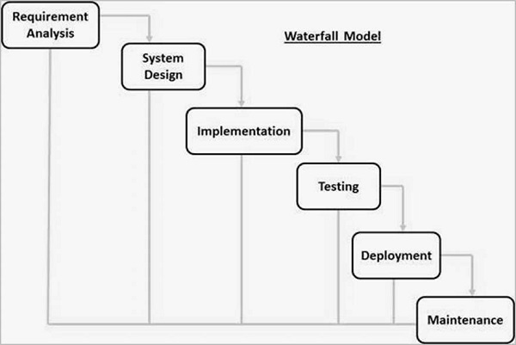

(Tutorialspoint.com, n.d.)

* V-Model

The V-Model is named as such because of the shape of the model in diagrams. It’s a relatively simple, linear model that relies on three steps, namely analysis/design, production, and testing. Much like with the waterfall model, the overall simplicity of this model allows it to be used for projects of almost any size, as the process is very easy to follow and adapt to most use-cases. (Tutorialspoint.com, n.d.) (Powell-Morse, 2016)

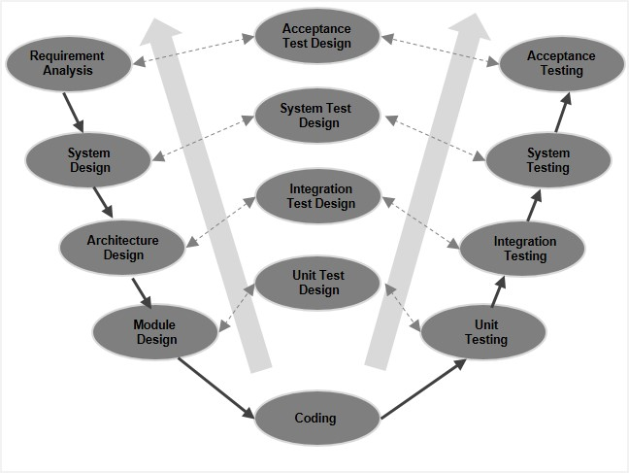

(Tutorialspoint.com, n.d.)

* Spiral Model

This model involves four major steps: identification, design, construction, and evaluation. The benefits of this model are that each step is that each iteration involves evaluation and design, rather than with a sequential model where design only takes place at the start, and there’s little expectation for it to take place further into a project. This model also involves lots of user interaction, which helps with identification of requirements. (Tutorialspoint.com, n.d.) (GeeksforGeeks, n.d.)

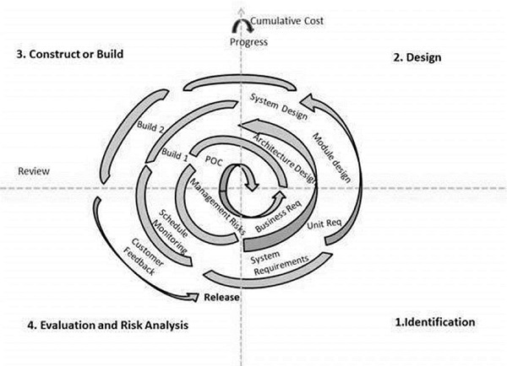

(Tutorialspoint.com, n.d.)

* Agile Model

Agile is much more freeform compared to the previous models illustrated, as it allows for various amounts of input from a set of teams, each focussing on their own task; planning, design, requirement analysis, testing, and production. Each iteration can last if needed, and usually each iteration results in a prototype or a set of completed features. (Tutorialspoint.com, n.d.) (GeeksforGeeks, n.d.)

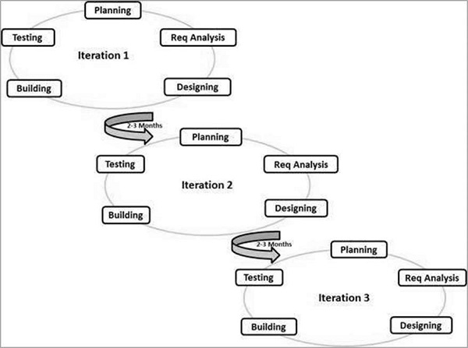

(Tutorialspoint.com, n.d.)

Bibliography:

Tutorialspoint.com. (n.d.). SDLC - Waterfall Model - Tutorialspoint. [online] Available at: https://www.tutorialspoint.com/sdlc/sdlc_waterfall_model.htm [Accessed 3 Oct. 2019].

Powell-Morse, A. (2016). Waterfall Model: What Is It and When Should You Use It? [online] Airbrake Blog. Available at: https://airbrake.io/blog/sdlc/waterfall-model [Accessed 3 Oct. 2019].

Tutorialspoint.com. (n.d.). SDLC - V-Model - Tutorialspoint. [online] Available at: https://www.tutorialspoint.com/sdlc/sdlc_v_model.htm [Accessed 3 Oct. 2019].

Powell-Morse, A. (2016). V-Model: What Is It And How Do You Use It? [online] Airbrake Blog. Available at: https://airbrake.io/blog/sdlc/v-model [Accessed 3 Oct. 2019].

Tutorialspoint.com. (n.d.). SDLC - Spiral Model - Tutorialspoint. [online] Available at: https://www.tutorialspoint.com/sdlc/sdlc_spiral_model.htm [Accessed 3 Oct. 2019].

GeeksforGeeks. (n.d.). Software Engineering | Spiral Model - GeeksforGeeks. [online] Available at: https://www.geeksforgeeks.org/software-engineering-spiral-model/ [Accessed 3 Oct. 2019].

Tutorialspoint.com. (n.d.). SDLC - Agile Model - Tutorialspoint. [online] Available at: https://www.tutorialspoint.com/sdlc/sdlc_agile_model.htm [Accessed 3 Oct. 2019].

GeeksforGeeks. (n.d.). Software Engineering | Agile Development Models - GeeksforGeeks. [online] Available at: https://www.geeksforgeeks.org/software-engineering-agile-development-models/ [Accessed 3 Oct. 2019].